6.88:
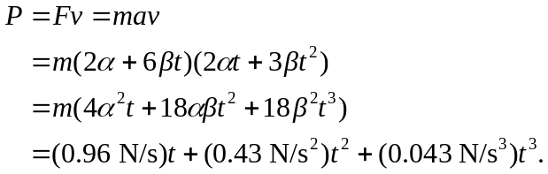

At 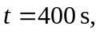 the power output is 13.5 W.

